+ Academic: -  English: - Revision of letters Aa, Bb, Cc Letter Dd, Ee, Ff Introduction Writing  Oral: -A to Z phonic sounds with two objects.  Hindi: - Oral: - Swar-  Written: - Swar …………..  Math’s: - written: -Number 1-5, related exercise  Oral: - Counting 1 to 10  E.V.S.: - Revision of Parts of plant, Body parts name  New topic - Monsoon season, safety rules on road, at home, at school  Pre-Math’s Concept: - Revision of previous topics, Tall/ short  Colors /Shapes: Green/ Cube  Activities: -  Fine Motor Skills Gross Motor Skills  1. vegetable painting 1. Yoga/ Zumba  2 leaf impression 2. Exercise  3. clay molding 3. Hopping / Jumping  4. Moong daal pasting 4. Line the tag  5. Balancing  6. Tracing  7. Follow the rules | 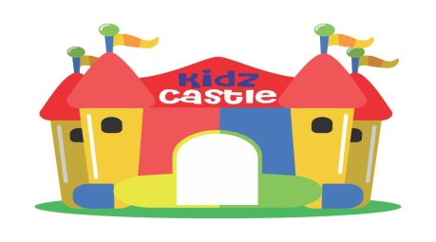  KIDZ CASTLE  Monthly Bulletin July’2023  Class- Nursery
Class- Nursery  Events of the month-  Blow the cup activity - 7 ‘July’23  * Story telling competition - 17 July’23  **Nutrition week celebration - 17- 21’July’23  Green color Nature walk - 19 ‘july’23  Traffic light Activity -12 ‘july’23  Monsoon party -31 July’23  Note: -* Prepare a Hindi moral story for story telling competition with prop  * Nutrition week- (children will bring green color food in their tiffin for whole week 17- 21 July’23  Holidays of the month-  Shiv Ratri 15th July’23  Morning Activity: -  Pronunciation of Gayatri Mantra, Prayer, Yoga, National Anthem, Pledge.  Slogan of the Month: -  “Eat Green Be healthy”  Magic Words: - Pardon, please, May i  Action Words: - Eat, wash, work  Concept of the Month: - Traffic light, Safety rules  General Questions: -  1.What is the other name of rainy season? | Q2. Name the season after which monsoon season comes?  Q3. Name of the months are called rainy months?  Q4. Which kind of cloth we wear in rainy season?  Q5. What we like to eat in rainy seasons?  Q6. What kind of footwear we wear in rainy season to keep dry our feet?  Q7. What we like to float in water puddle in the rainy season?  Eng Rhymes: -  Hindi Rhymes: -  Story of the month: - Related to Shiv Ratri  This Photo by Unknown Author is licensed under CC BY-NC-ND

