+ Academic: -  English: - Revision of letters A, B, C with phonic sound, D, E, F Introduction with activity  Oral: -A to Z phonic sounds with two objects.  Math’s: - Introduction of number 1,2and 3  Oral: - Counting 1 to 5  E.V.S.: - Body parts name New topic - Monsoon season, Traffic light , Green color fruits and vegetable name  Pre-Math’s Concept: - Revision of previous topics, Tall/ short  Colors /Shapes: Green/ square  Activities: -  Fine Motor Skills Gross Motor Skills  1. vegetable painting 1. Yoga/ Zumba  2 leaf impression 2. Exercise  3. clay molding 3. Hopping / Jumping  4. Paper boat making 4. Line the tag  5. Balancing  6. Tracing  7. Follow the rules | 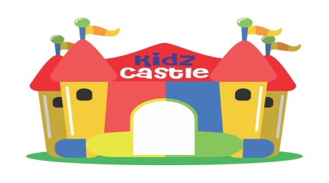  KIDZ CASTLE  Monthly Bulletin’July’2023  Class- Pre-Nursery
Class- Pre nur  Events of the month-  Blow the cup activity - 7 ‘July’23  *Show & Telling competition - 17 July’23  ** Nutrition week celebration - 17- 21’July’23  Green color Nature walk - 19 ‘july’23  Traffic light Activity -12 ‘july’23  Monsoon party -31 July’23  Note: -  * Make a fruit or vegetable prop i.e. (cutout/puppet) for show & tell competition (Name of fruit and colour)  **Nutrition week- (children will bring green color food in their tiffin for whole week 17- 21 July’23 like green salad , green puri, green veg, green chilla , green sandwich etc.  Holidays of the month-  Shiv Ratri 15th July’23  Morning Activity: -  Pronunciation of Gayatri Mantra, Prayer, Yoga, National Anthem, Pledge.  Slogan of the Month: -  “Eat Green Be healthy”  Magic Words: -  Pardon, please, May I  Action Words: - Eat, wash, work  Concept of the Month: - Traffic light, Safety rules  General Questions: -  1.What is the other name of rainy season? | Q2. Name of five fruits name?  Q3. Name any five vegetables name ?  Q4. How many sense organ we have?  Q5. Name any two red color fruits?  Q6. Name any two yellow colour objects?  Q7. Name any two Green fruits and two vegetables ?  Eng Rhymes: -  Hindi Rhymes: -  Story of the month:- Story related to Shiv Ratri  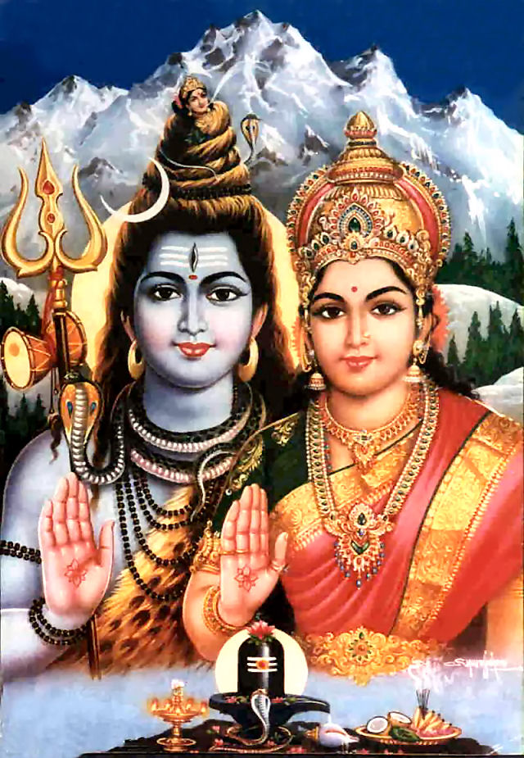  This Photo by Unknown Author is licensed under CC BY-NC-ND

